Math 342: Homework 5

Connor Emmons

Documentation: I used ChatGPT solely for looking up Latex commands. The main Homework 5 MatLab script and all required dependencies are located in the Homework 5 folder found here: <https://github.com/Connor-Lemons/Emmons-Math-342>. No other resources used.

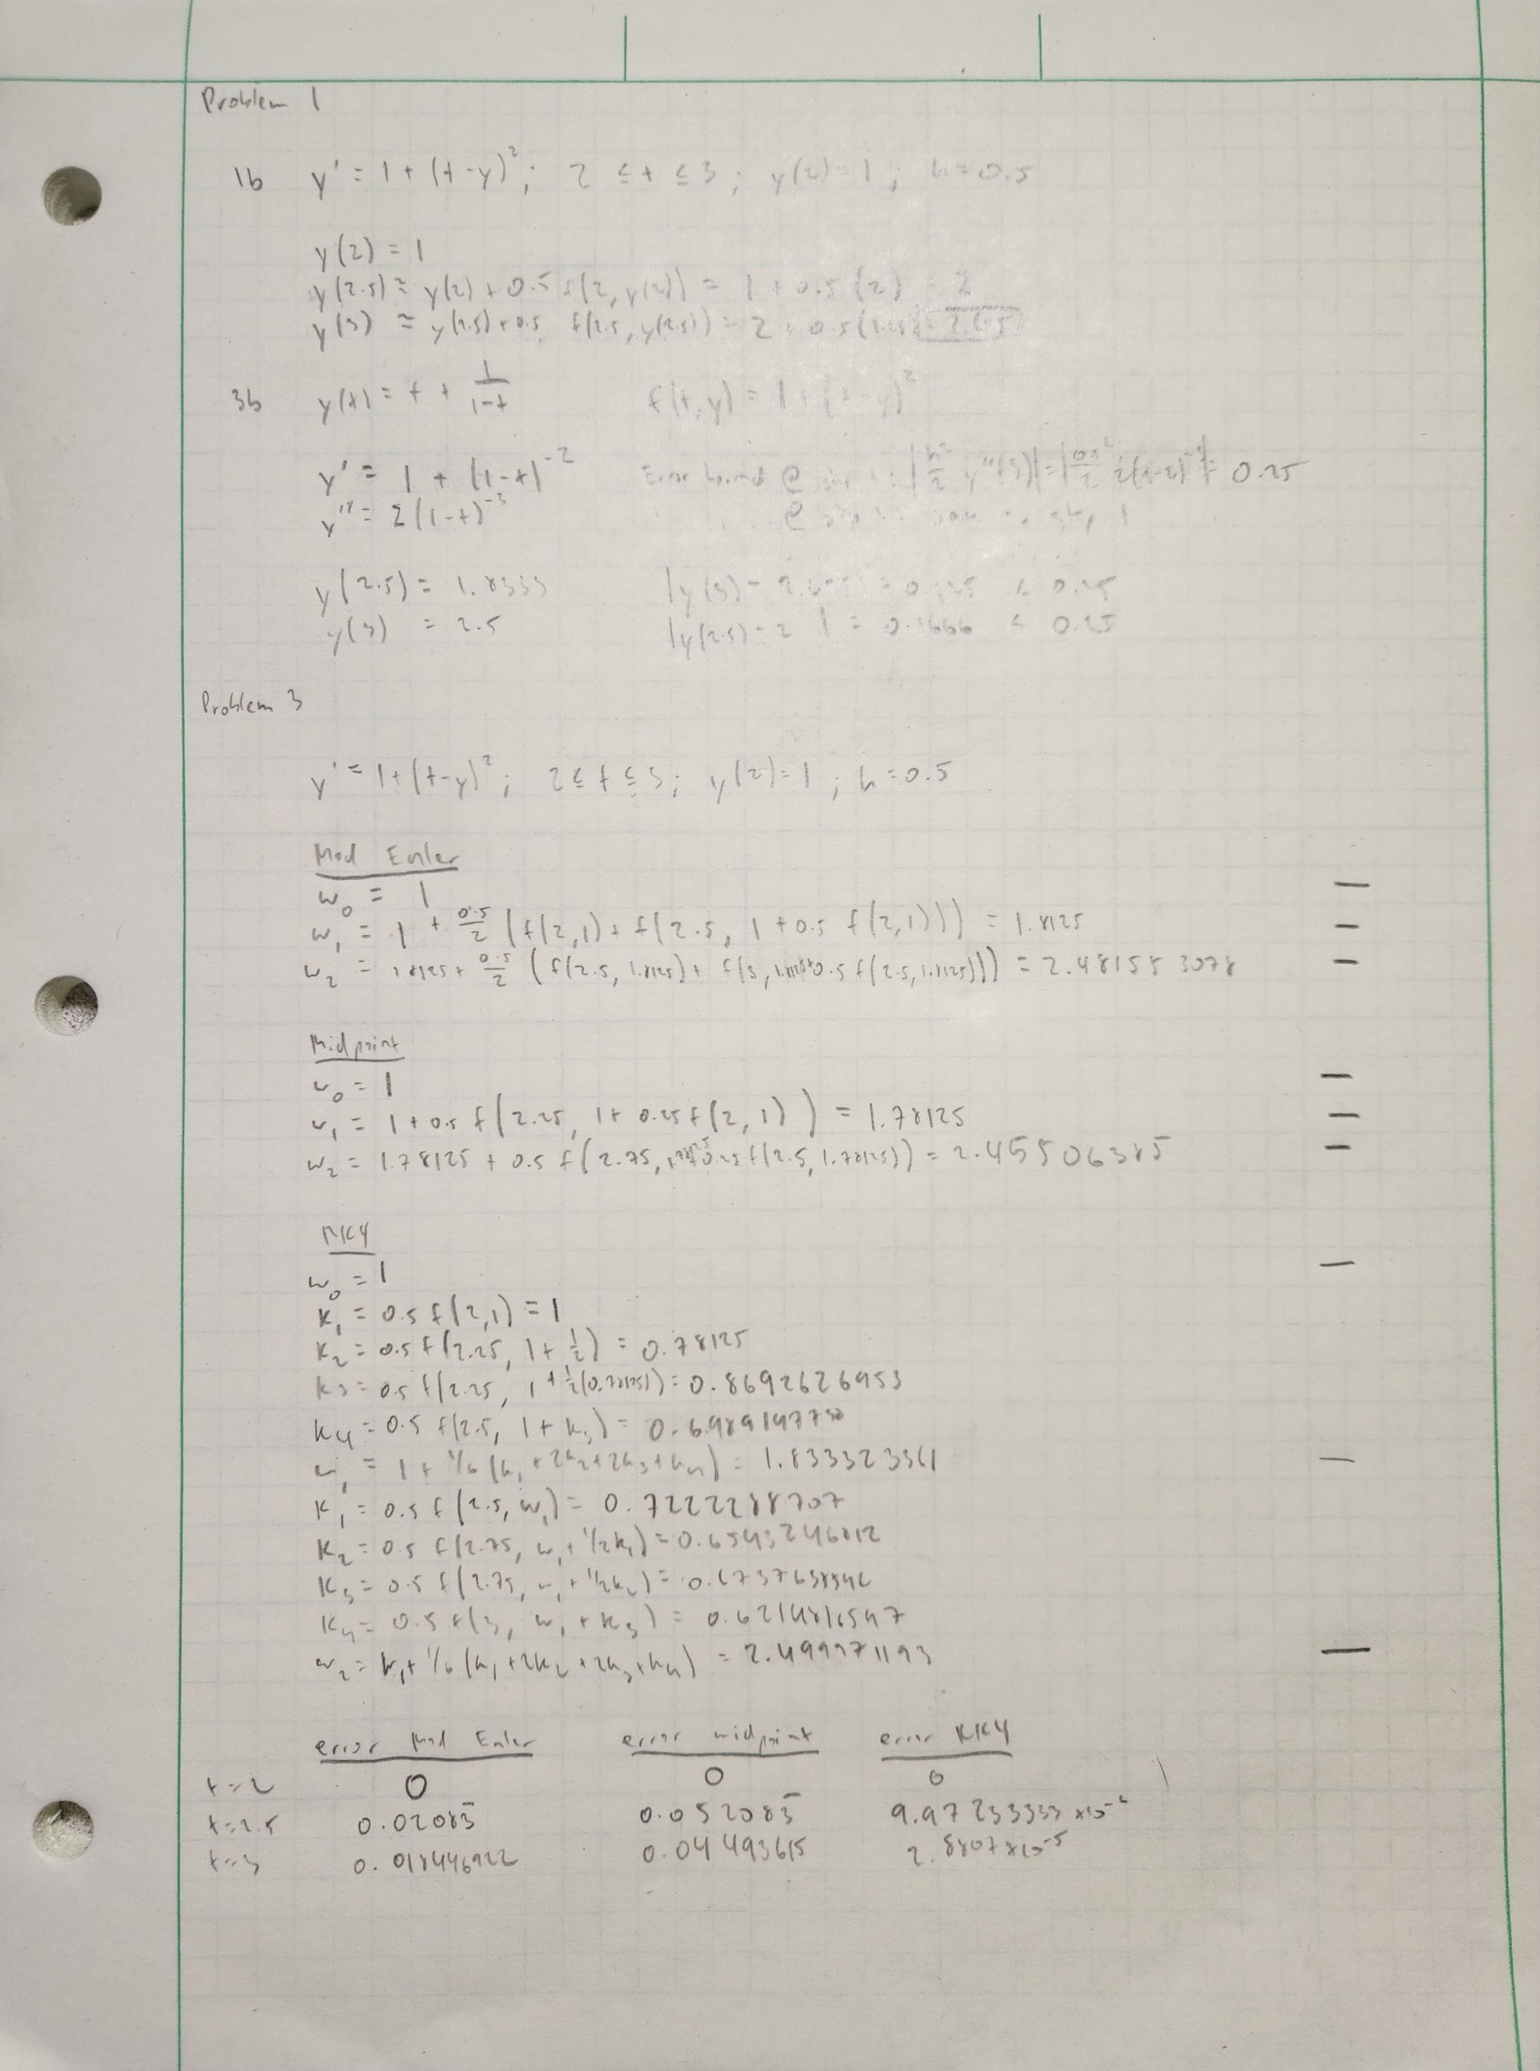

Problem 2

The output of the code is:

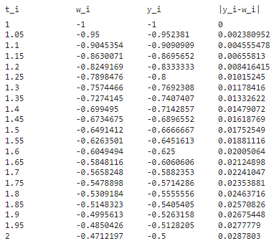

Code can be found attached at the end or in the GitHub.

The error is stable because each step increases the error by roughly 0.002.

In order to find the Lipschitz constant, take the derivative of $f\left(t,y\right)$ with respect to $y$:

$\frac{df}{dy}=-\frac{1}{t}-2y$ (1)

Because $y=-\frac{1}{t}$,

$\frac{df}{dy}=-\frac{1}{t}-2\left(-\frac{1}{t}\right)=\frac{1}{t}$ (2)

On the interval $t∈\left[1,2\right]$, the following inequality is true:

$\frac{1}{t}≤1$ (3)

The second derivative of $y$ is:

$y''=-\frac{2}{t^{3}}$ (4)

On the interval $t∈\left[1,2\right]$, the following inequality is true:

$\left|y''\right|<2$ (5)

Thus $L=1$ and $M=2$. Equation 5.10 gives:

$0.05=\frac{hM}{2L}\left[e^{L\left(t_{i}-a\right)}-1\right]$ (6)

Plugging in and solving for $h$ yields $h=0.0291$.

Problem 4

The output of the code is:

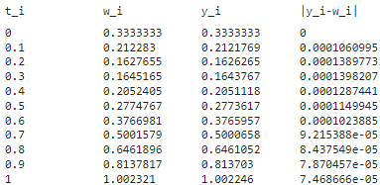

Code can be found attached at the end or in Github.

Problem 5

RK4 output:

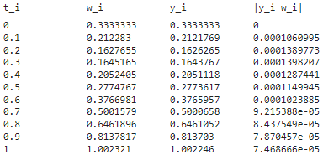

Adams-Bashforth 2-Step:

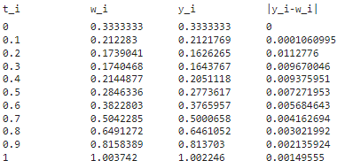

Adams-Bashforth 3-Step:

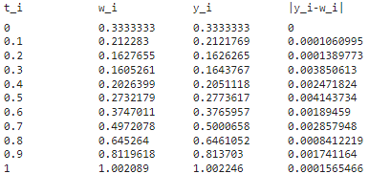

Adams-Bashforth 4-Step:

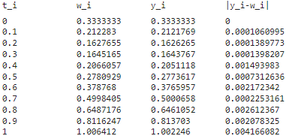

Adams-Bashforth 5-Step:

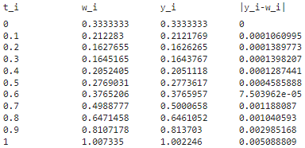

Adams-Bashforth 4-Step with Predictor:

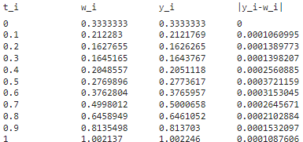

Code can be found attached at the end or in Github.

In this specific case, RK4 produced the best result with a final error of 7.47e-5.

Problem 6

This is the graph for the 1000 prey, 500 predators case:

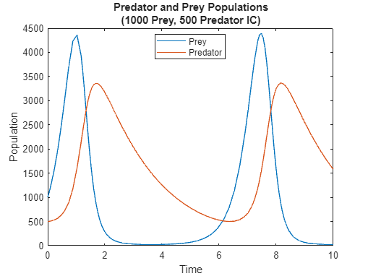

Note that, at least over the course of 10 units of time, the system does not reach any sort of equilibrium. To find the equilibrium points, solve for $x_{1}^{'}=x_{2}^{'}=0$. This gives two potential points: $\left(0,0\right)$ and $\left(833.333,1500\right)$. To test if these equilibrium points are stable, run the solver with a small deviation to these conditions. This is the graph for 1 prey, 0 predators (representing a small deviation from the case $\left(0,0\right)$):

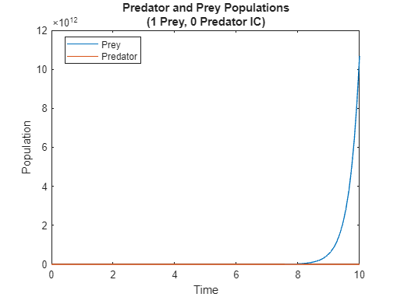

Note that the population blows up, and thus this is not a stable point. This is the graph for 840 prey, 1490 predators (representing a small deviation from the case $\left(833.333,1500\right)$):

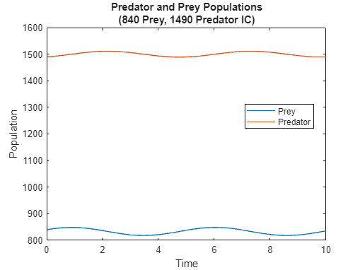

Note that the populations of each species oscillate around a constant value, which indicates that this point is marginally stable (a truly stable point would drive both populations to a constant value).